**About the Project**

This is an application to enable Grazioso Salvare to use a data-driven approach while identifying promising candidates for dog search and rescue training. It uses a classic 3-tier application architecture with a database layer, a middleware/backend layer, and a client/front-end layer. MongoDB was used as the database component, and the Python Dash framework was used as the backend and client component. Another way to explain the architecture would be MongoDB as the model, and Dash as the view/controller. The company requires a dashboard featuring an interactive data table, map widget, and an additional chart. Above all, the solution needs to be user-friendly and intuitive. All of these requirements are satisfied as evidenced in the Screenshot section further in the document.

**Motivation**

Grazioso Salvare’s primary goal for this application is to analyze data from animal shelters. They have identified key traits and characteristics they are looking for in dogs and need a way to efficiently find animals that meet the criteria.

**Steps Taken to Complete Project**

First, a database with authentication and authorization controls was created with MongoDB. The database was populated with the Austin Animal Center Outcomes data using the mongoimport tool. Next, a CRUD module was created with Python and pymongo to enable create, read, update, and delete operations against the database. Finally, the client was created using the Dash framework which functions as both the view and controller layer of the application.

**Challenges Faced**

The biggest challenge faced during the development of this project was figuring out how to write queries against MongoDB. It is very different from SQL, and it took a lot of research and trial and error to get all of the queries worked out to filter the data to meet the requirements.

**Getting Started**

Here are the steps needed to set up the database, create an authenticated user, and leverage the AnimalShelter class to perform CRUD operations:

1. Load the data into MongoDB:  
   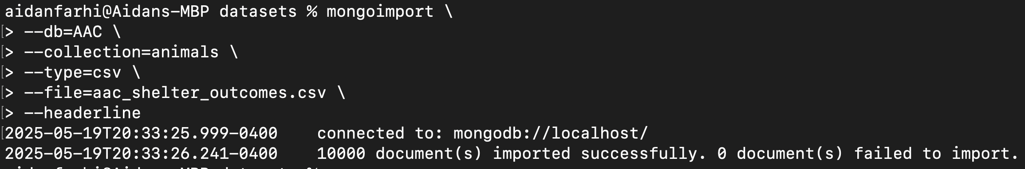
2. Create a user to access the database:  
   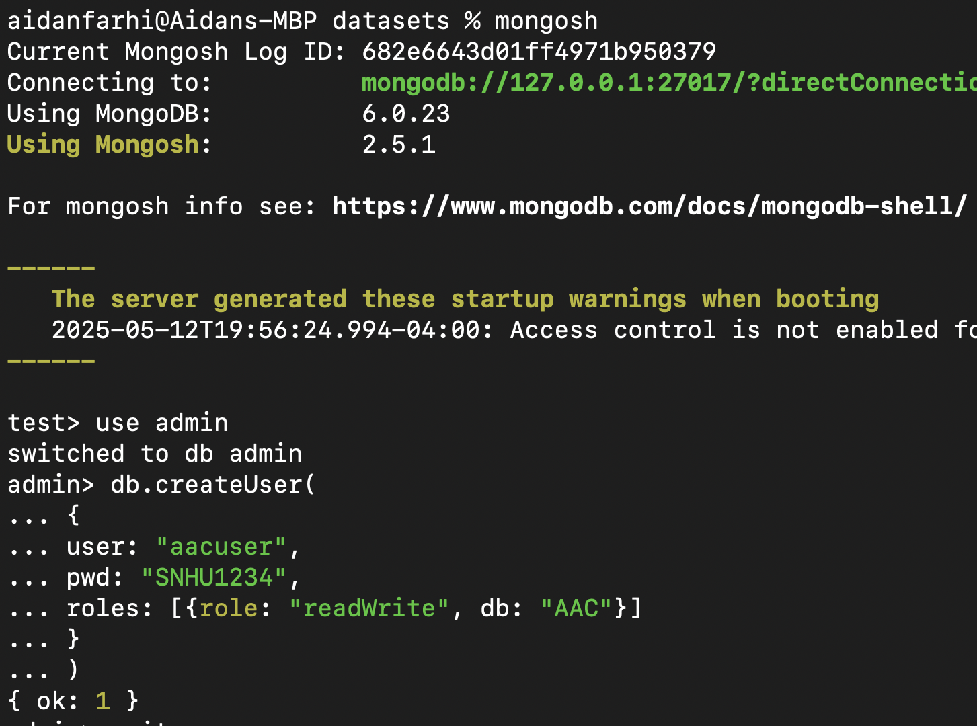
3. Create a directory, go into the directory, create a virtual environment, and install the dependencies:  
   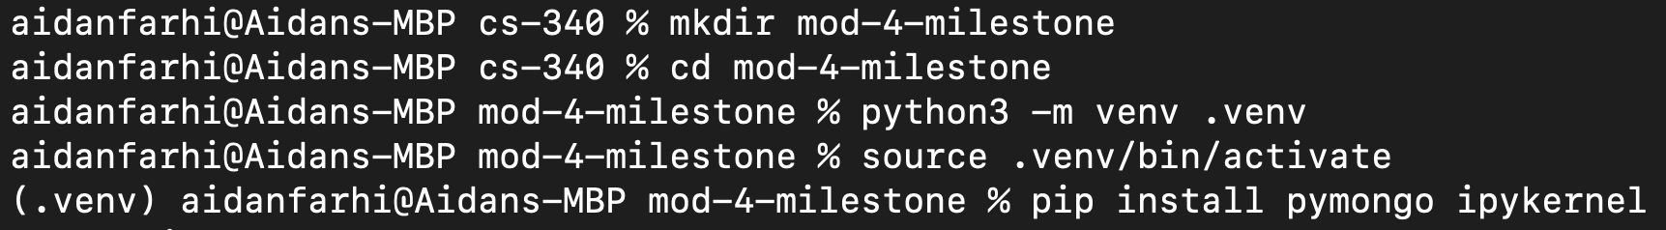
4. Create a file named **animal_shelter.py** and put the following code into it:  
     
   https://raw.githubusercontent.com/AidanFarhi/cs340-mod-4-assignment/refs/heads/main/animal_shelter.py
5. Create a file called **.env** and put the following values in it:  
     
   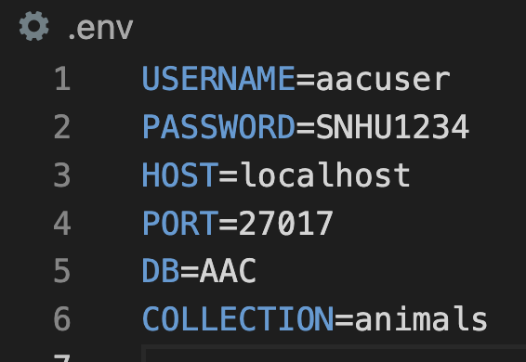
6. Install the Jupyter extension for VSCode:  
     
   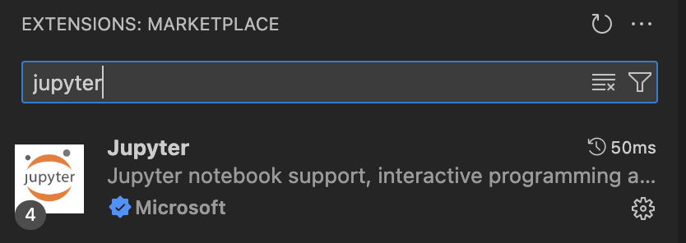
7. Create a Jupyter notebook and import the AnimalShelter class:  
     
   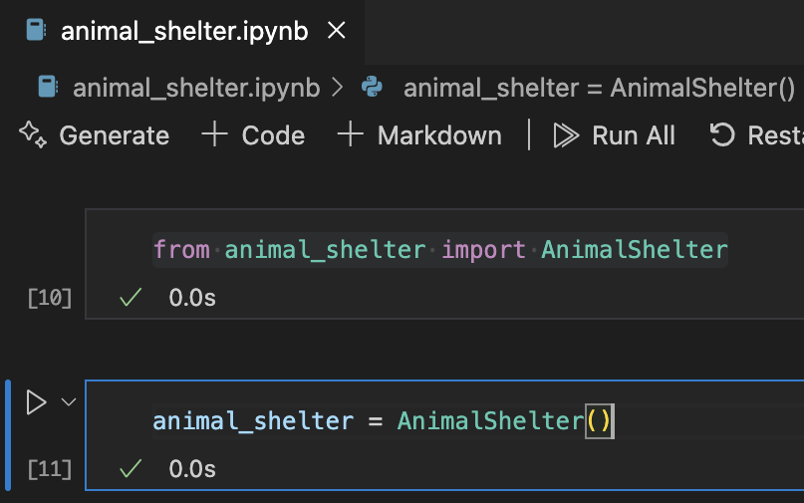

The CRUD module setup was fairly straightforward. To start with, I created a collection with MongoDB using the mongoimport tool and a CSV file. I also created an authenticated user to access the database. After that, I wrote the AnimalShelter class to implement Create and Read functionality. Finally, I used a Jupyter Notebook to test out the AnimalShelter class. I found the useability of the pymongo library to be intuitive. I did not have any issues finding the relevant documentation for the API. While creating a user within the database and importing the CSV file, I had to heavily reference the course materials. I’m still somewhat new to MongoDB style querying. I don’t find it as intuitive as writing standard SQL queries.

**Installation**

Here are the tools that were used to create this project:

* MongoDB
* The mongosh and mongoimport CLI programs
* Python
* VSCode
* Jupyter Notebook
* The pymongo Python library
* The Dash framework

Here are some links to the tools and software used:

https://www.python.org/

https://www.mongodb.com/

https://code.visualstudio.com/

https://jupyter.org/

https://pymongo.readthedocs.io/en/stable/

https://dash.plotly.com/

**Usage**

**Python CRUD Module**

A module was created to perform create, read, update, and delete operations

within the MongoDB database. The python library pymongo was used because it

is the official python driver for MongoDB and features an intuitive and easy-to-use API.

The module allows for a client to import the module and leverage the AnimalShelter class to

perform all necessary operations.

**Examples of using the module and class:**

**animal_shelter.create(**

**{**

**"rec_num": 10001,**

**"age_upon_outcome": "5 months",**

**"animal_id": "A812345",**

**"animal_type": "Dog",**

**"breed": "Labrador Retriever Mix",**

**"color": "Brown/White",**

**.............**

**}**

**)**

This creates a new document within the animals collection. It will return True if successful  
 otherwise else it will return False.

**animal_shelter.find({"animal_id": "A812345"})**

This method will run a MongoDB find query against the animals collection within the database.

It will return either a list of objects that match the query or an empty list if no objects are found.

**animal_shelter.update({"animal_id": "A812345"}, {"$set": {"name": "Skippy"}})**

This method will update records within the animals collection of the MongoDB database.

It will return either a number for how many records were updated or zero if none were.

**animal_shelter.delete({"animal_id": "A812345"},)**

This method will delete records within the animals collection of the MongoDB database..

It will return either a number for how many records were deleted or zero if none were.

**Running the Dashboard**

First, install all of the requirements supplied in the code by running this command.  
 **pip install –r requirements.txt**

Next, open up the dashboard notebook code.

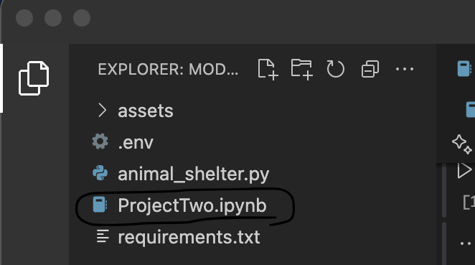

To run the dasboard, click the run button in the first cell.

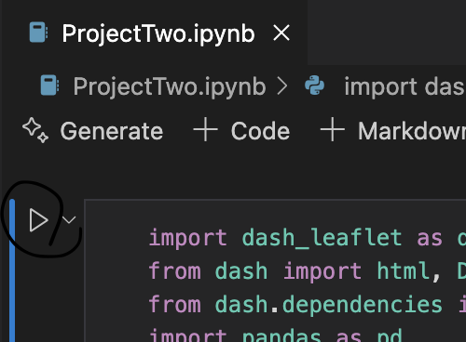

**Tests**

Here are the tests that were run after creating the AnimalShelter class:  
  
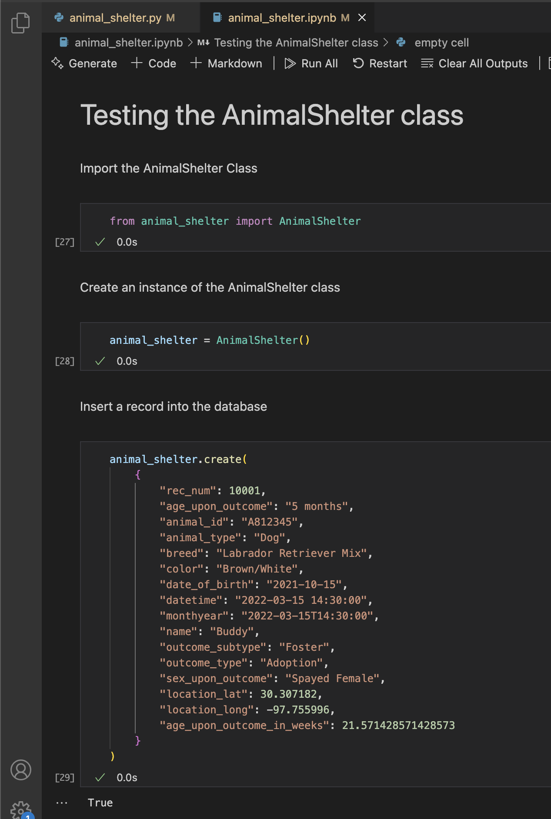

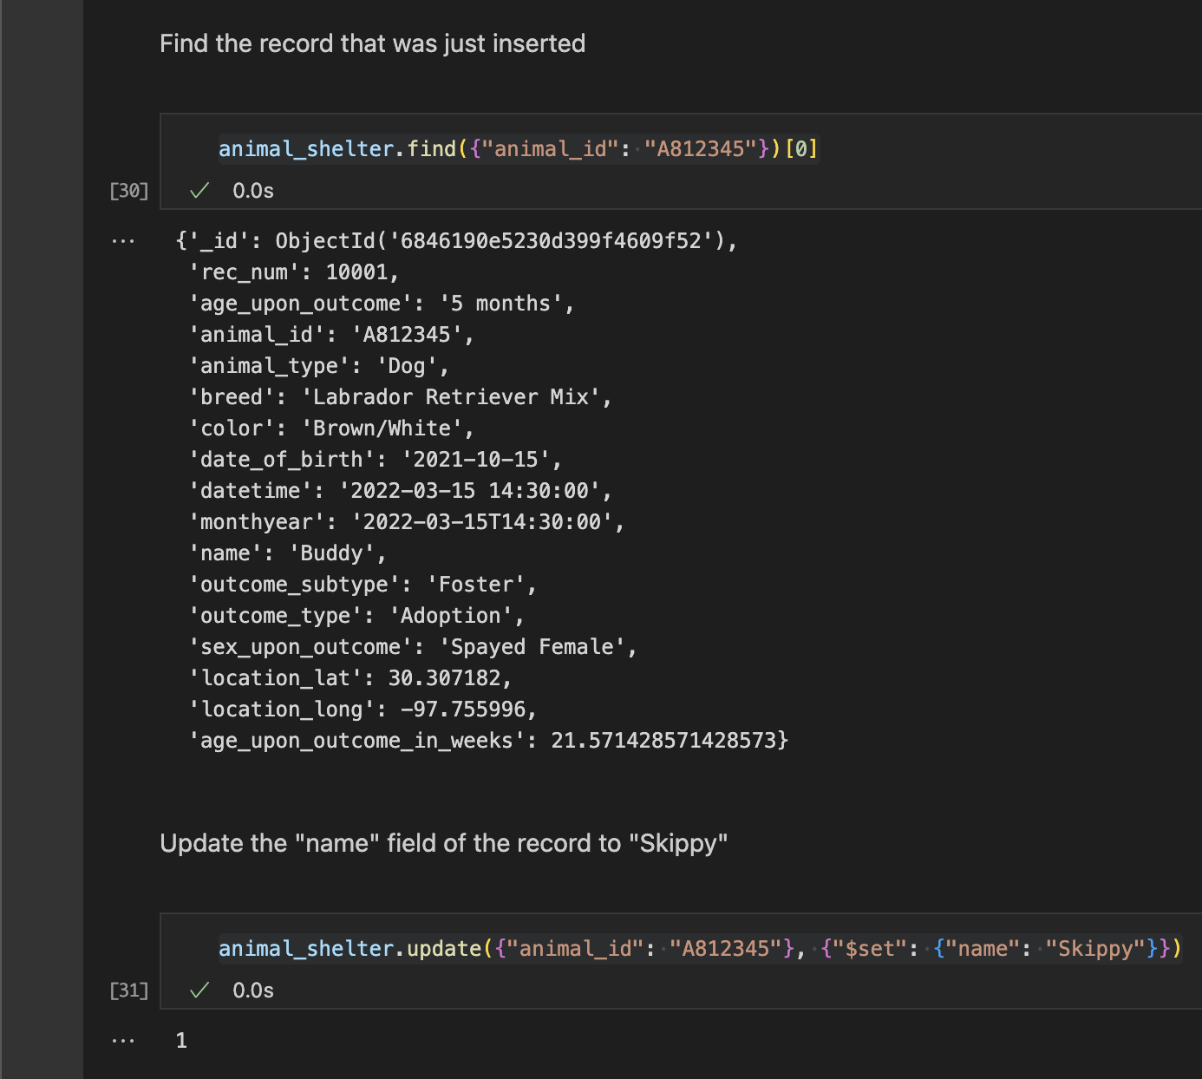

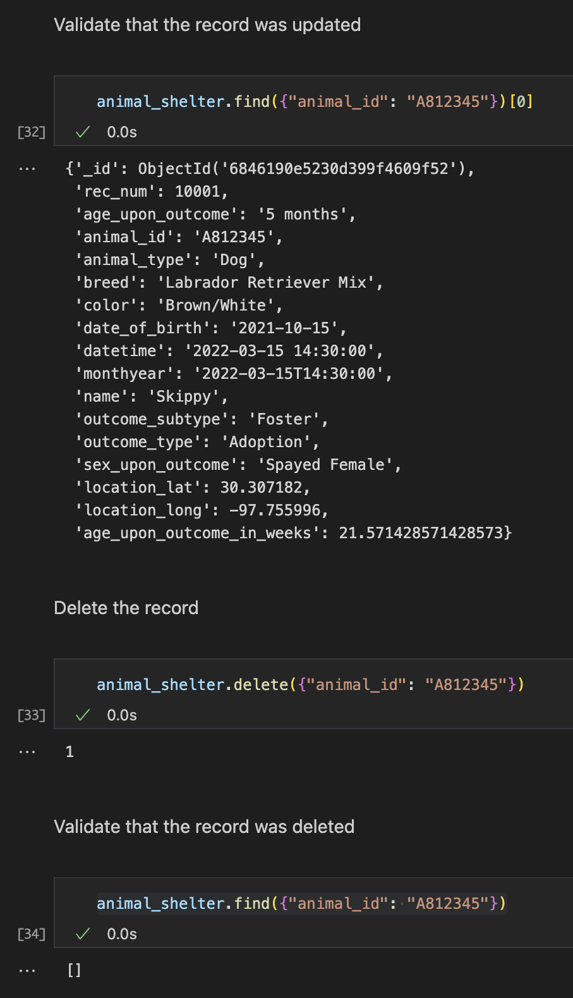

**Screenshots**

Here is an example of using python to update and query data within the database.

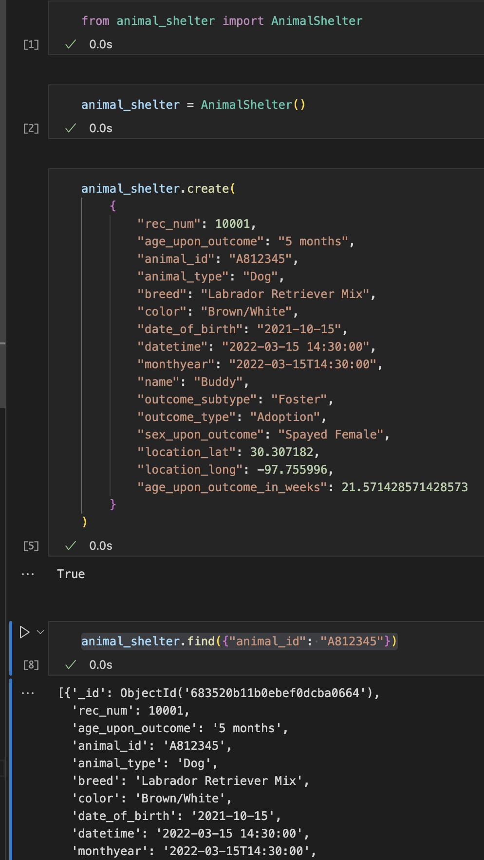

Dashboard - Starting state

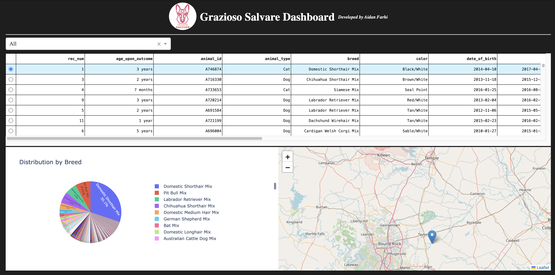

Dashboard - Water Rescue Filter Applied

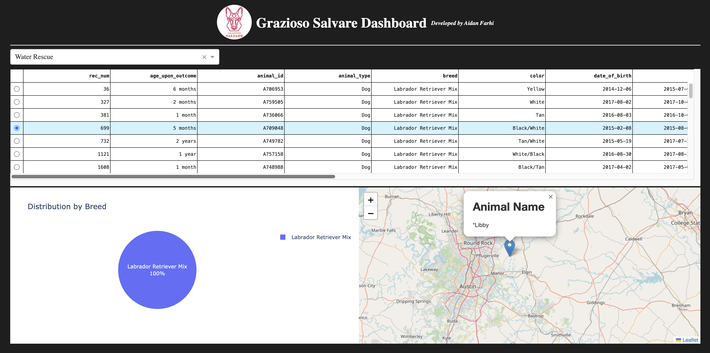

Dashboard - Mountain or Wilderness Rescue Filter Applied

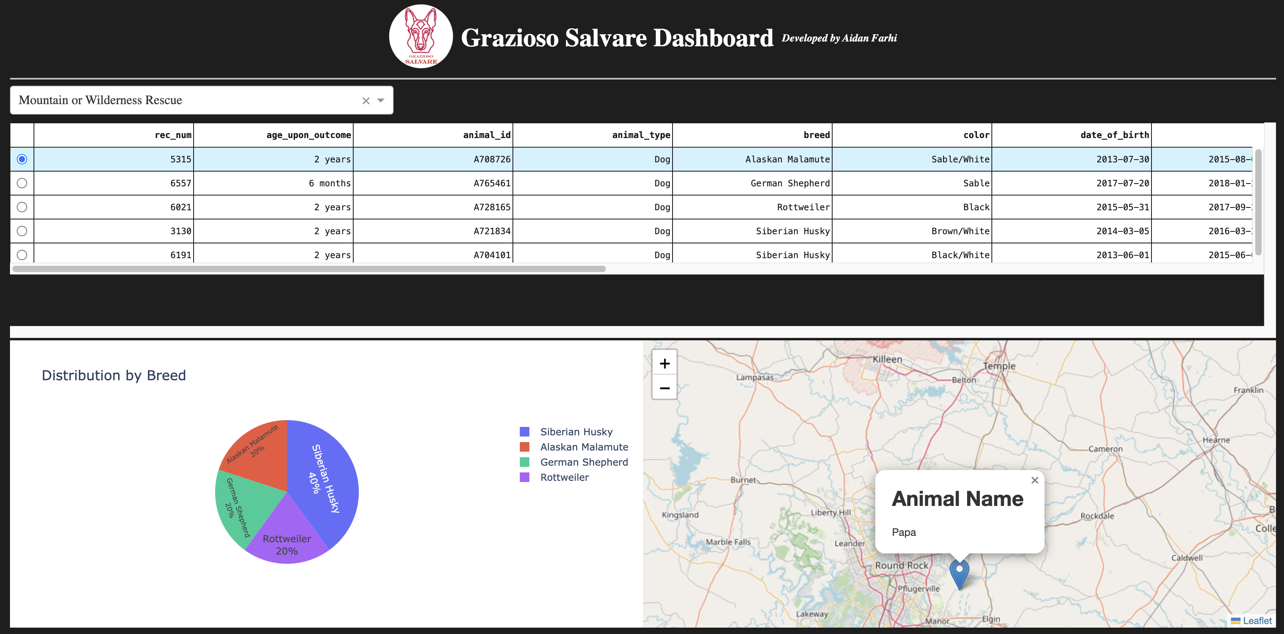

Dashboard - Disaster or Individual Tracking Filter Applied

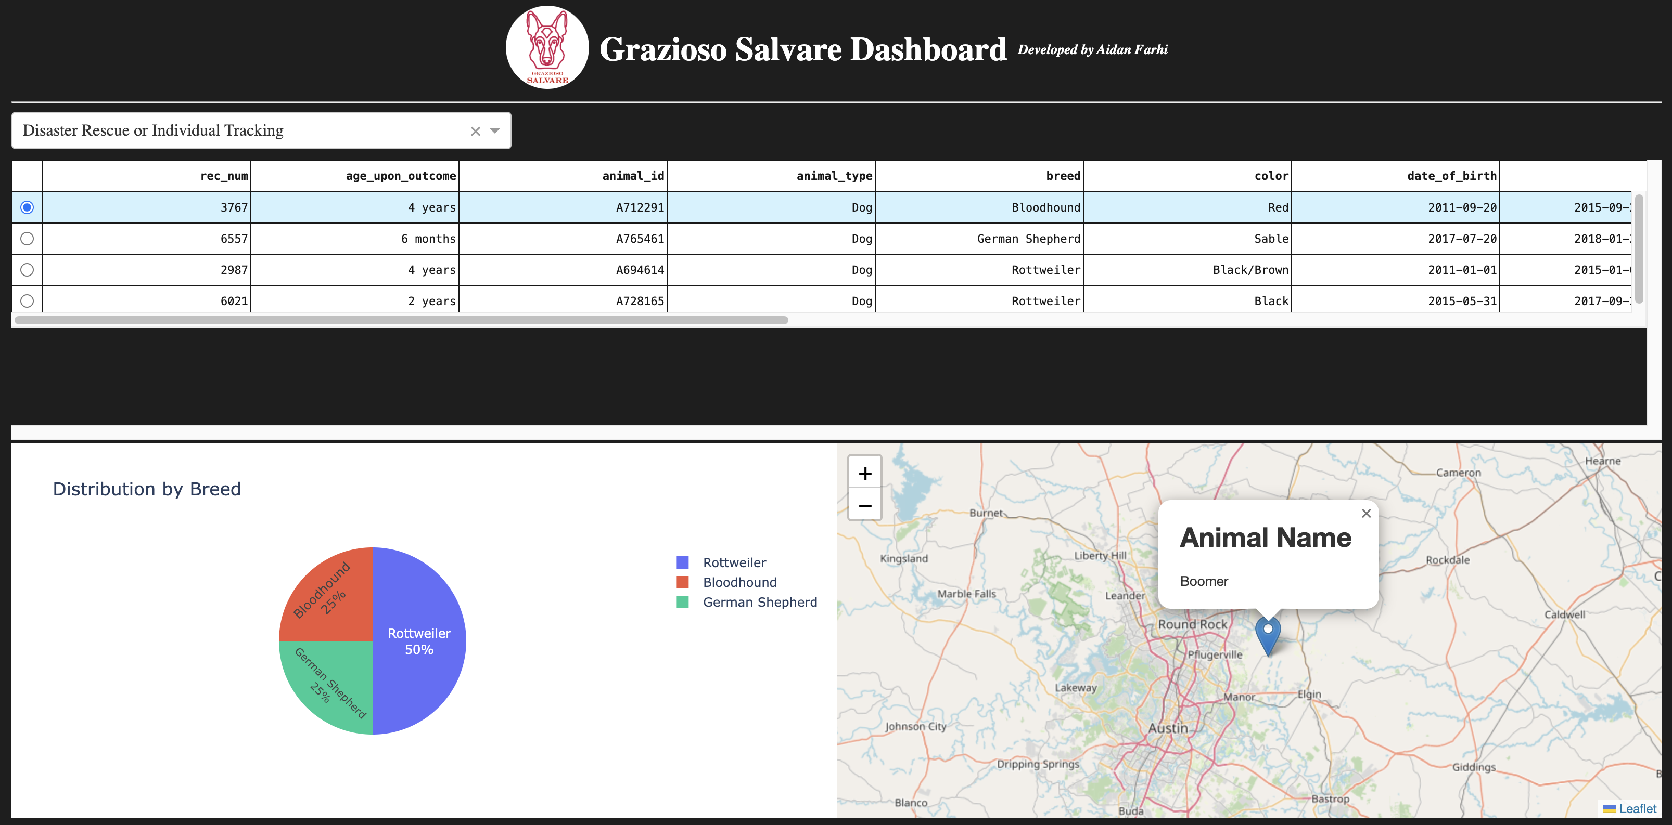

Dashboard - Reset Applied

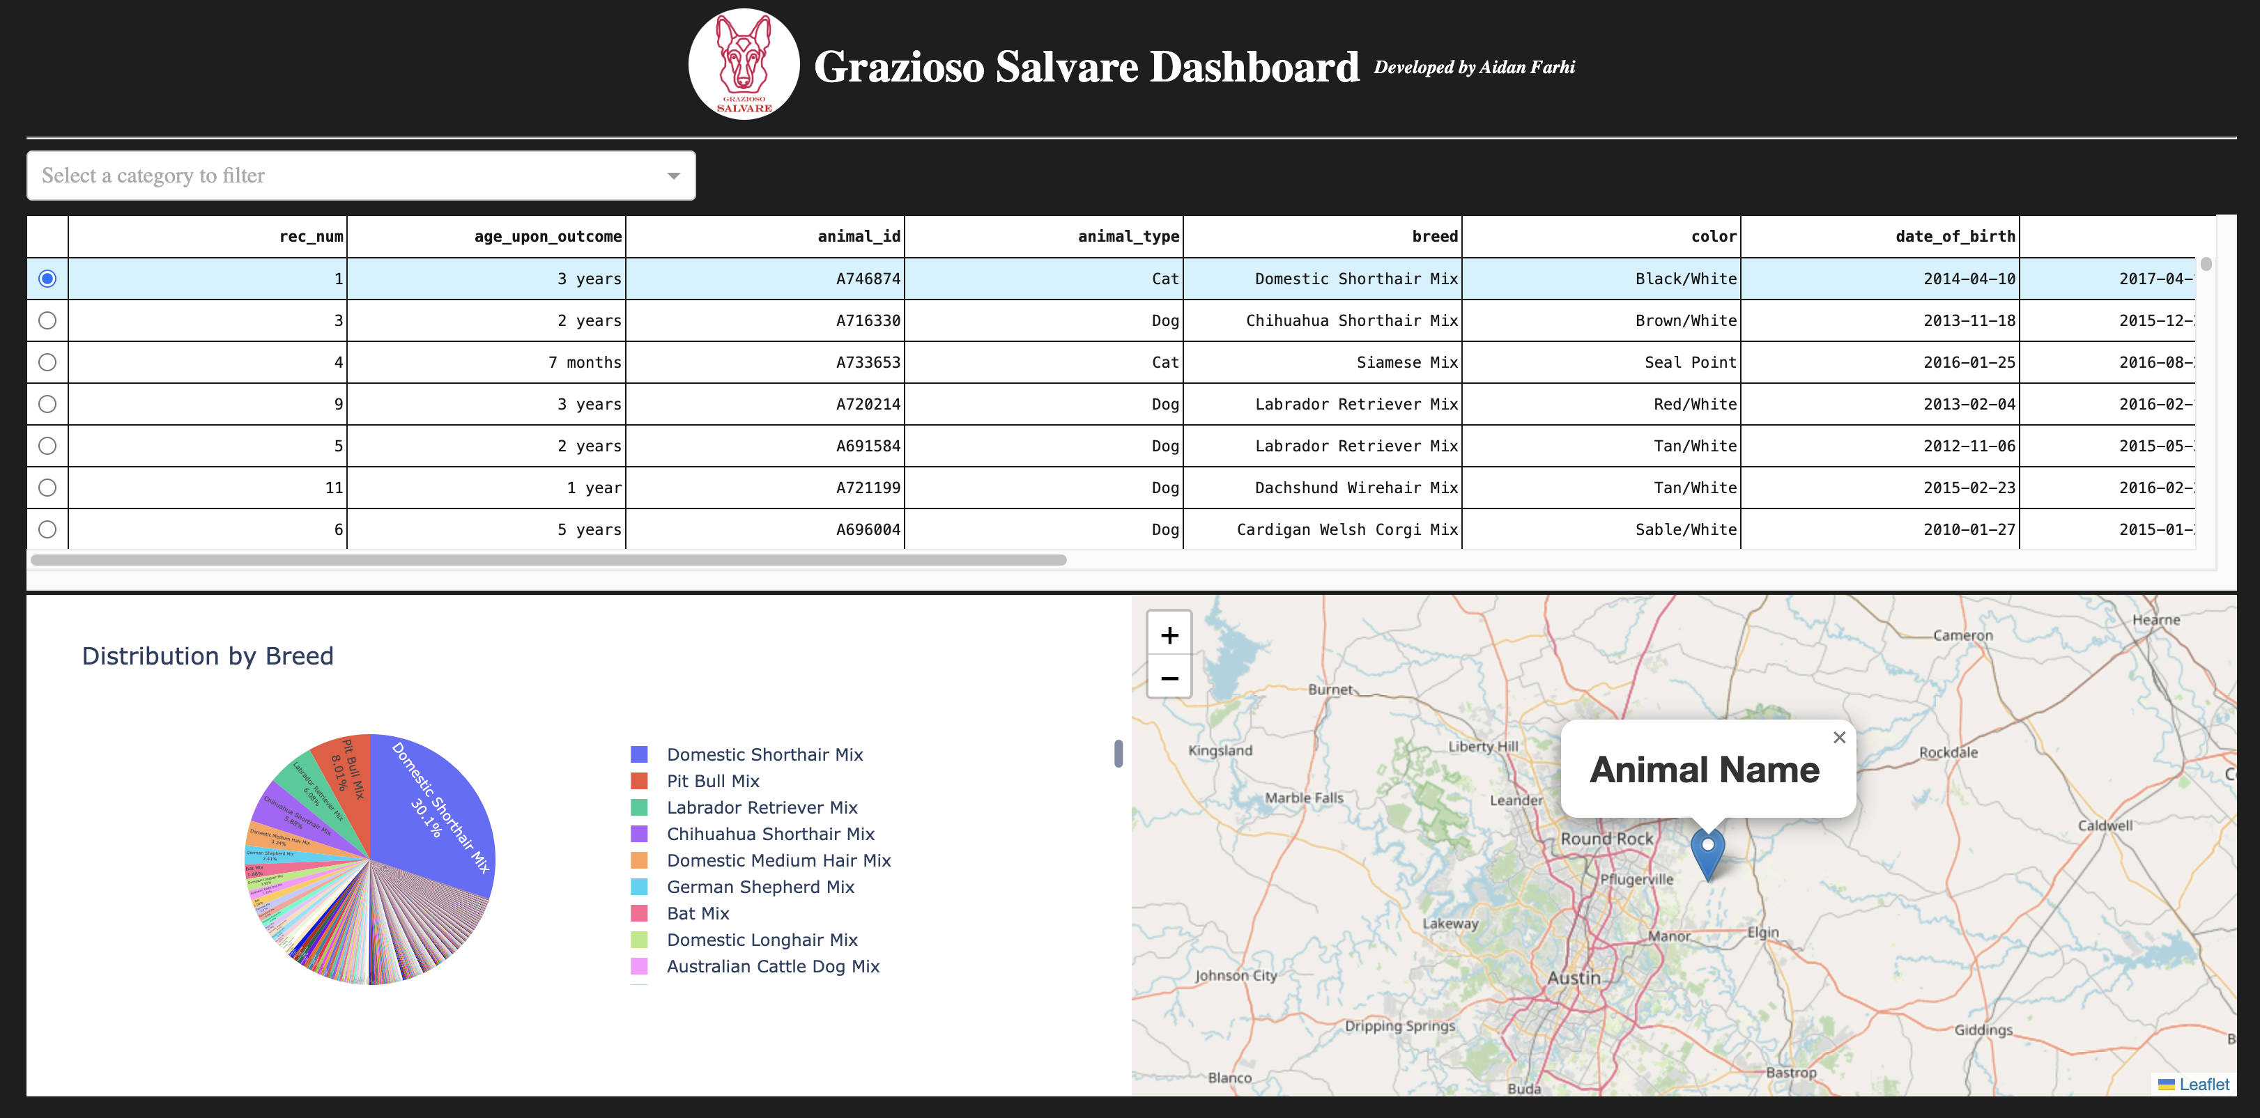

**Contact**

Aidan Farhi [<afarhidev@gmail.com](mailto:<afarhidev@gmail.com)>